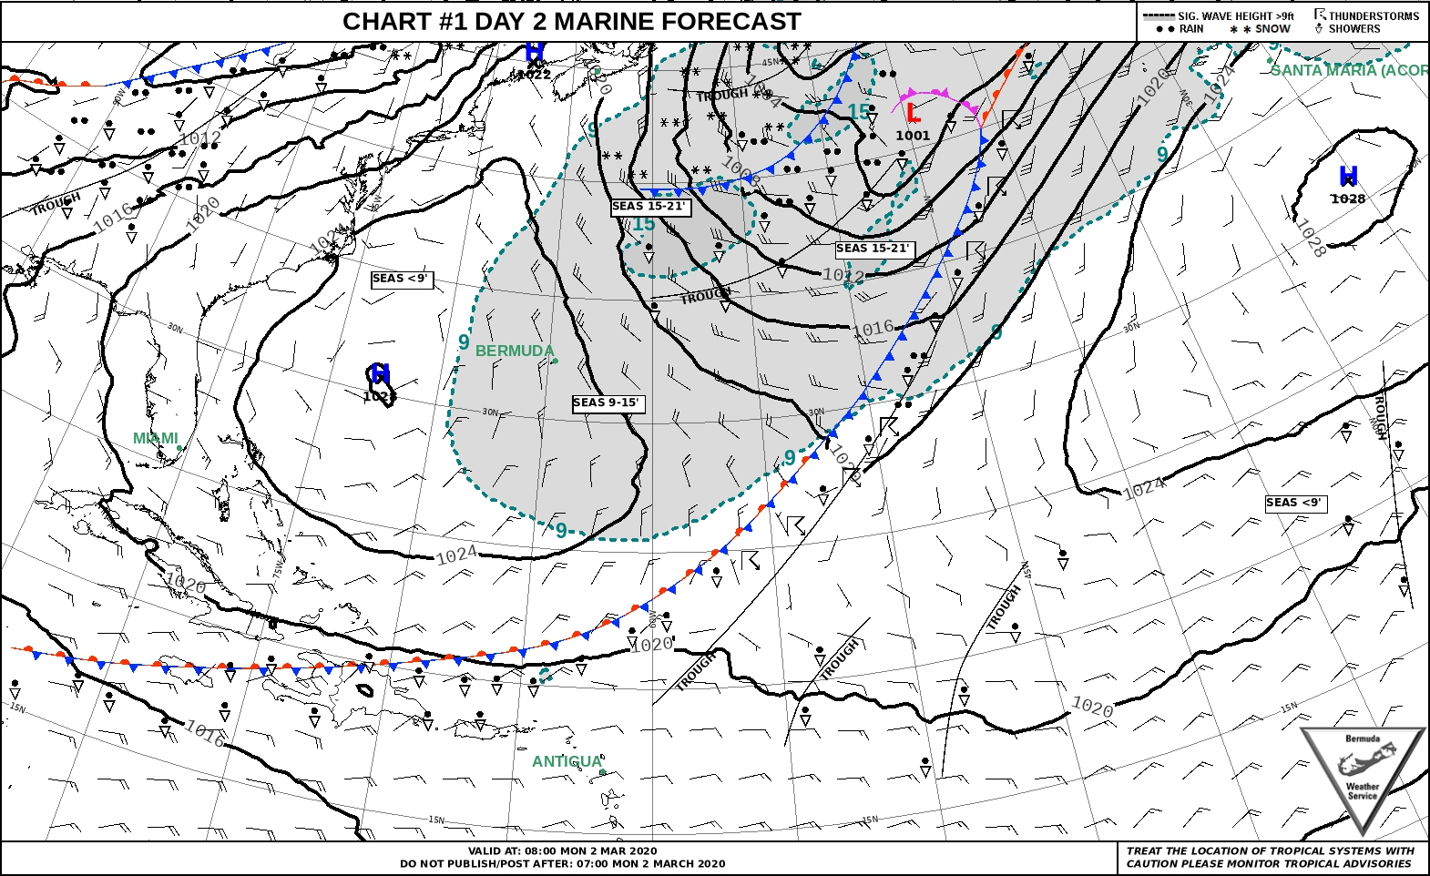

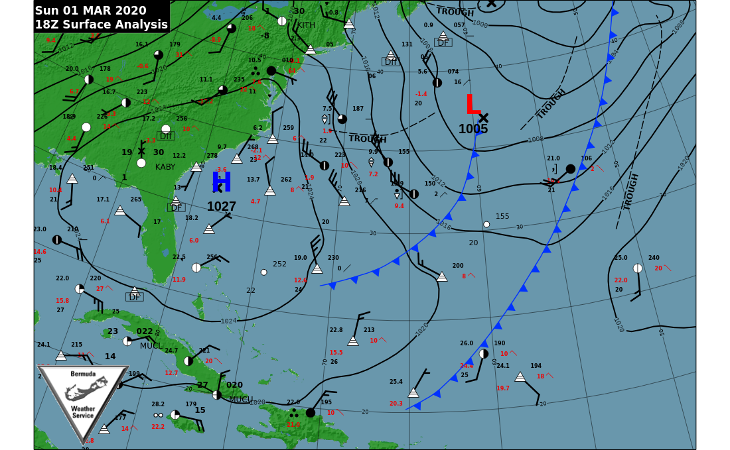

What does it mean by “Surface Analysis”?

What does 18Z mean?

What do you think the white triangle and white/black circles mean?

Draw an arrow or circle to locate the island.

Describe the weather that the island had recently experienced and explain what had happened.

**Identify the highlighted features**

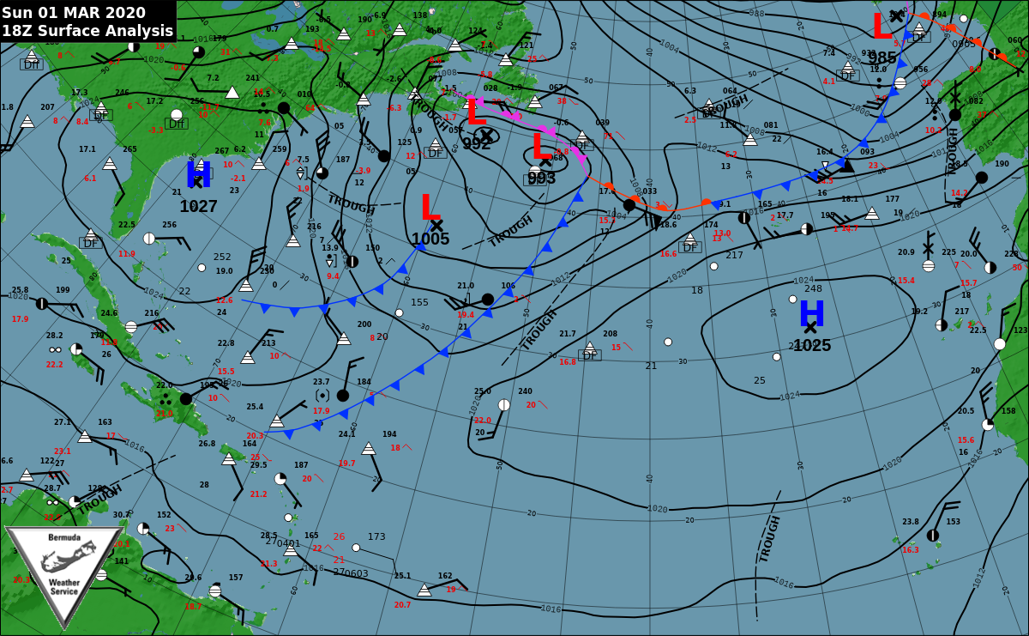

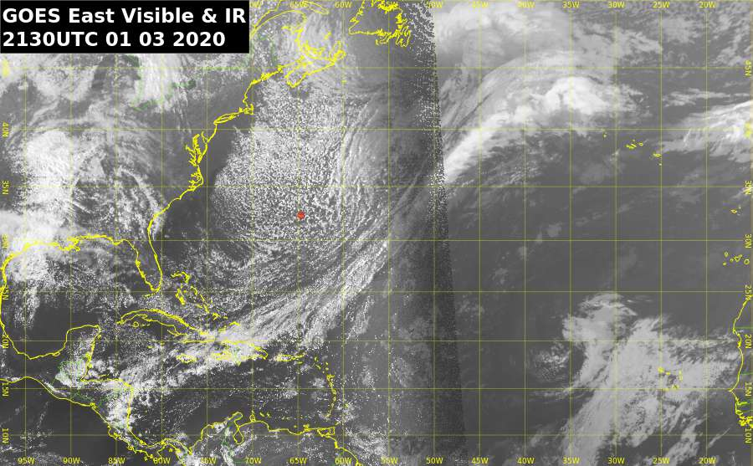

Compare this satellite image with the surface analysis and forecast chart. Identify the features that are shown on the charts on this satellite image.

What atmospheric features often follow behind a cold front?

Where is Bermuda?!

How does this compare in time to a) the surface analysis and b) the forecast chart?

How accurate is the forecast chart? GO ONLINE and see if you can find the satellite image that corresponds to the forecast chart. HOW CLOSELY MATCHED ARE THEY?

Look out the window and compare with reality.