OC 6.4 - Hurricanes

Hurricanes start life as thunderstorms that keep growing.

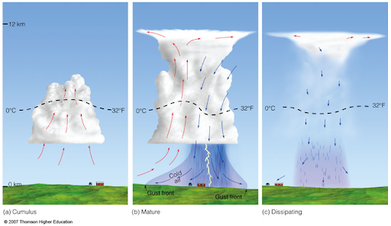

Why does water vapour condense as it rises?

Why does water vapour condensing release energy (heat)?

A thunderstorm over land dissipates as it releases its water. Why?
Hurricanes are large thunderstorms that are so big that the winds get deflected by the Coriolis Effect as they are drawn to the centre of the updraft.

They become HEAT ENGINES – i.e. turn heat energy into work.

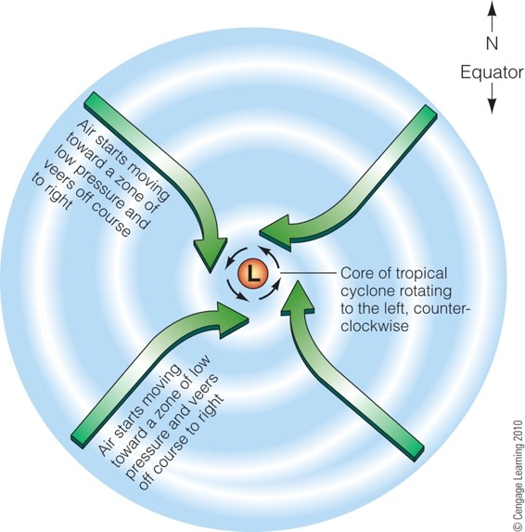
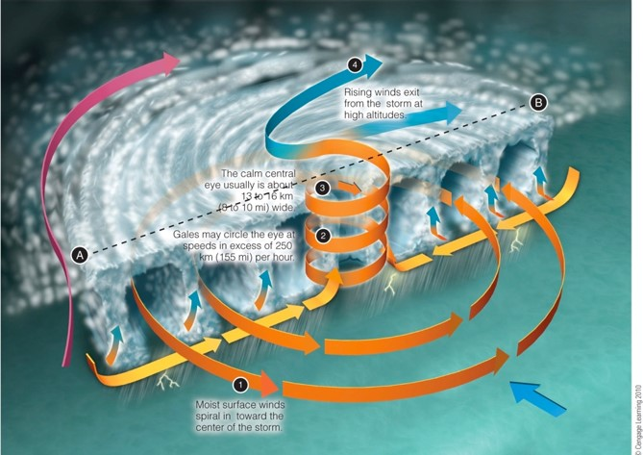
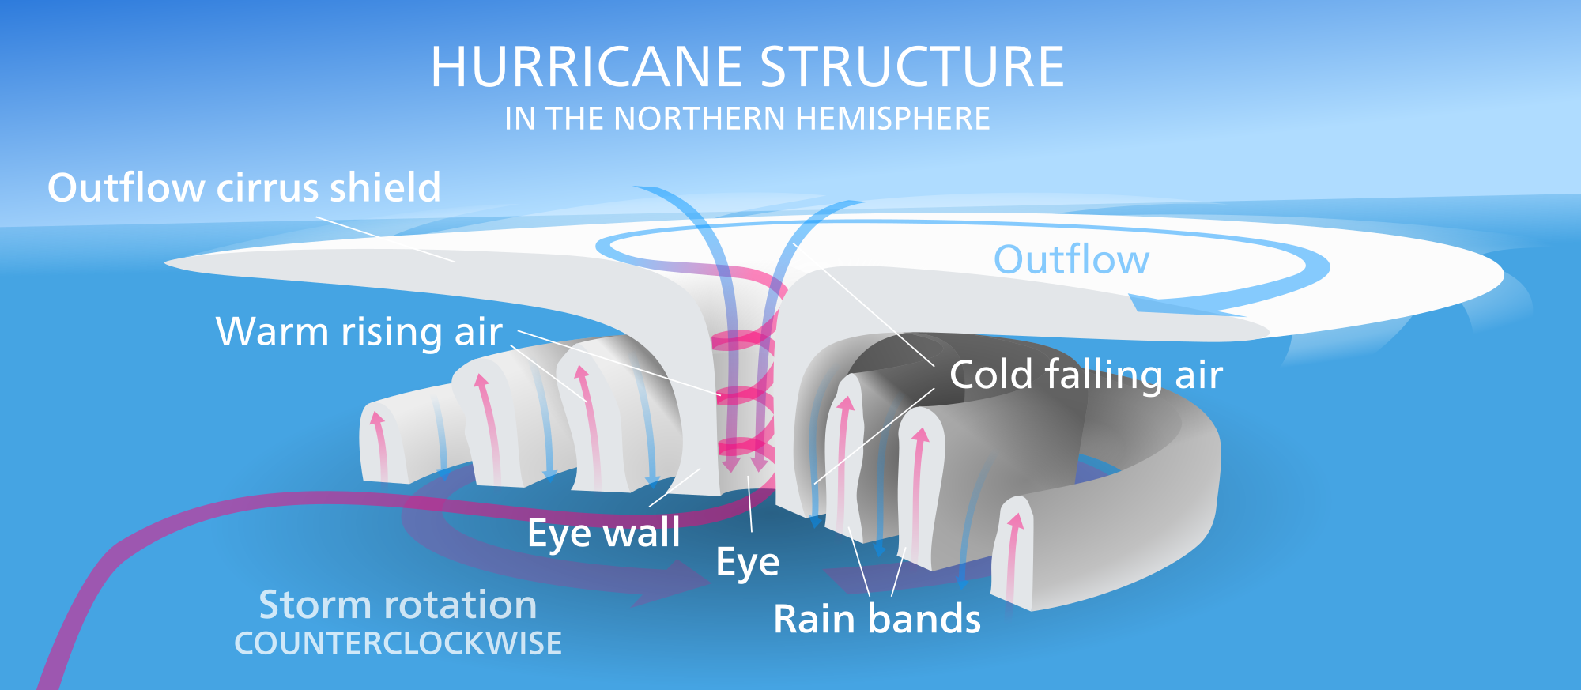
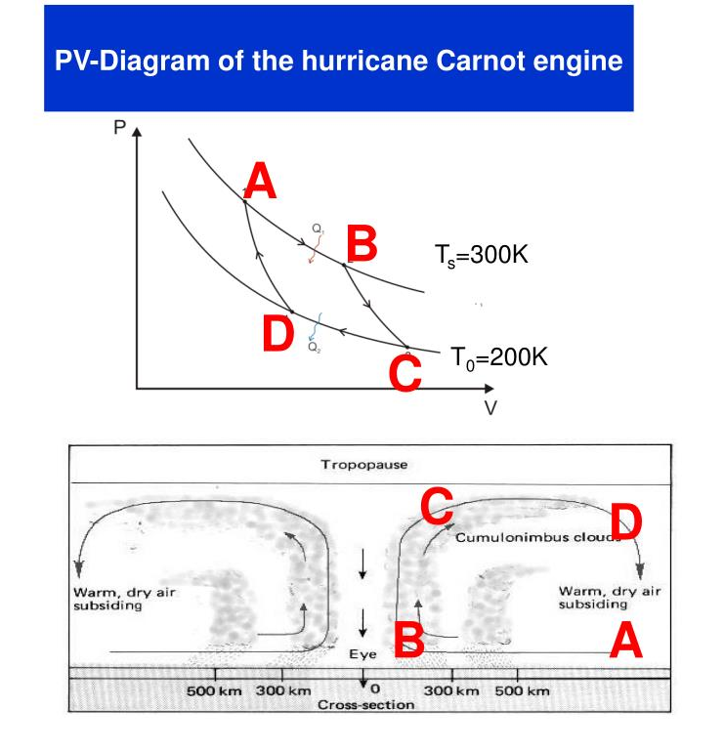

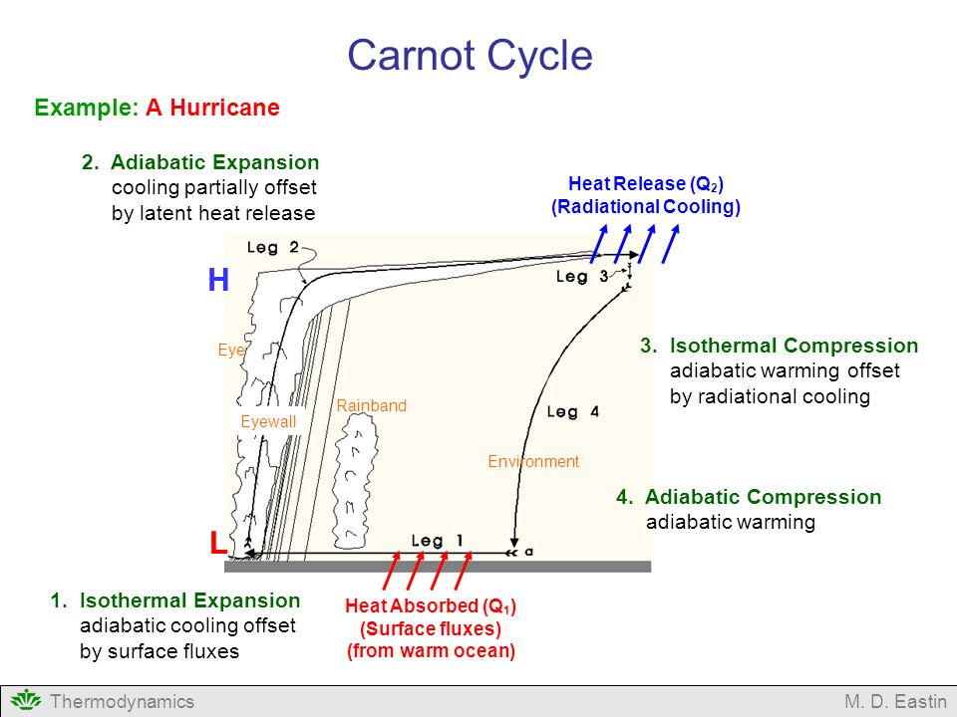
$$W=Q_{\left\{in\right\}}-Q_{\left\{out\right\}}$$
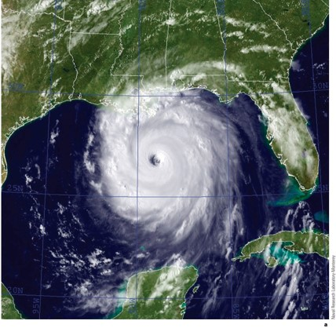
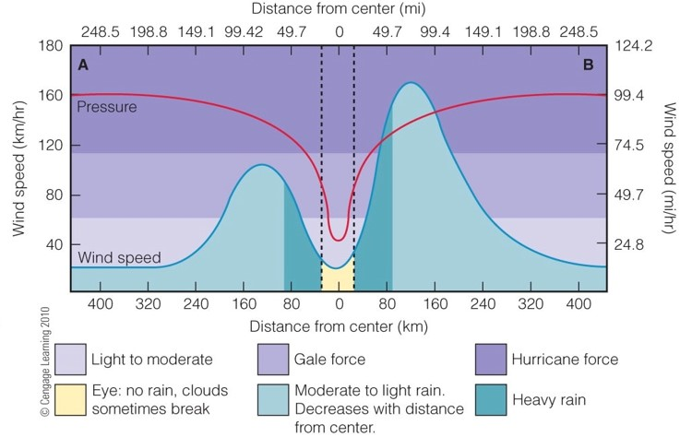

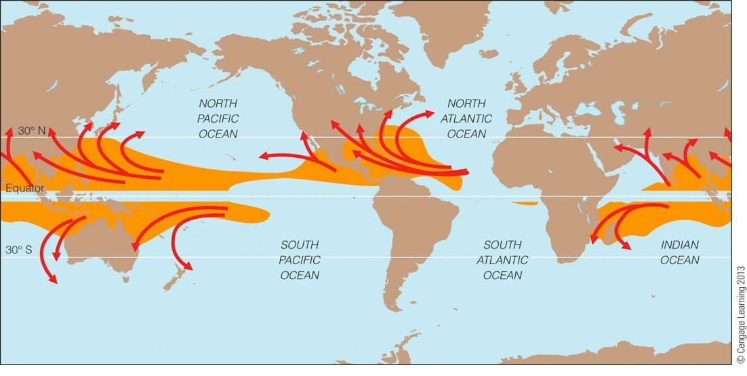
Where do hurricanes form?

Factors that enhance North Atlantic Hurricanes

Factors that suppress North Atlantic Hurricanes

Why do hurricanes recurve to the NE?

What steers hurricanes?

