OC 4.1 – Wave Properties Name: …………………………………….
(adapted from Exploring Our Fluid Earth)

- A wave has a wavelength of 24 m/wave and a period of 4 s. What is its speed?

- A wave has a speed of 3 m/s and a period of 20 s. What is its wavelength?

- The speed of a wave is 4.2 m/s. Its wavelength is 12.6 m. What is its period?

- What is the frequency of a wave with a period of 0.1 s?

- The frequency of a wave is 0.2 wave/s. What is its period?

- A diagram of a moving wave is shown below. Use this figure to answer the following questions:
      - What is the height of the wave?

      - What is the wavelength?

      - Can you calculate the frequency of the wave from this information? If so, what is it? If not, what additional information do you need?

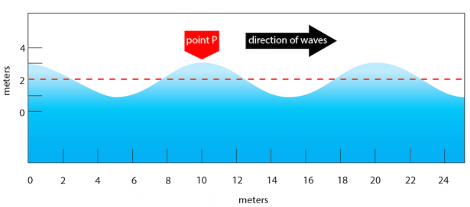

- The diagram above shows three wave crests moving to the right. When the crest of wave A passed point P, a watch reads 0.00 sec. When the crest of wave B passed point P, a watch reads 10.00 sec.
  - What is the period of the wave?

  - What is the speed of the wave?

  - What is the frequency of the wave?
- Check your understanding of the following terms by defining them in your own words:
  - Period
  - Wavelength
  - speed
  - frequency
  - height
  - crest
  - trough
  - profile

