OC 4.4 – Tidal Height Graph Name: ……………………………………

Location: St George’s, Bermuda
Date Range: ……………………………….
Moon Phase: ………………………………
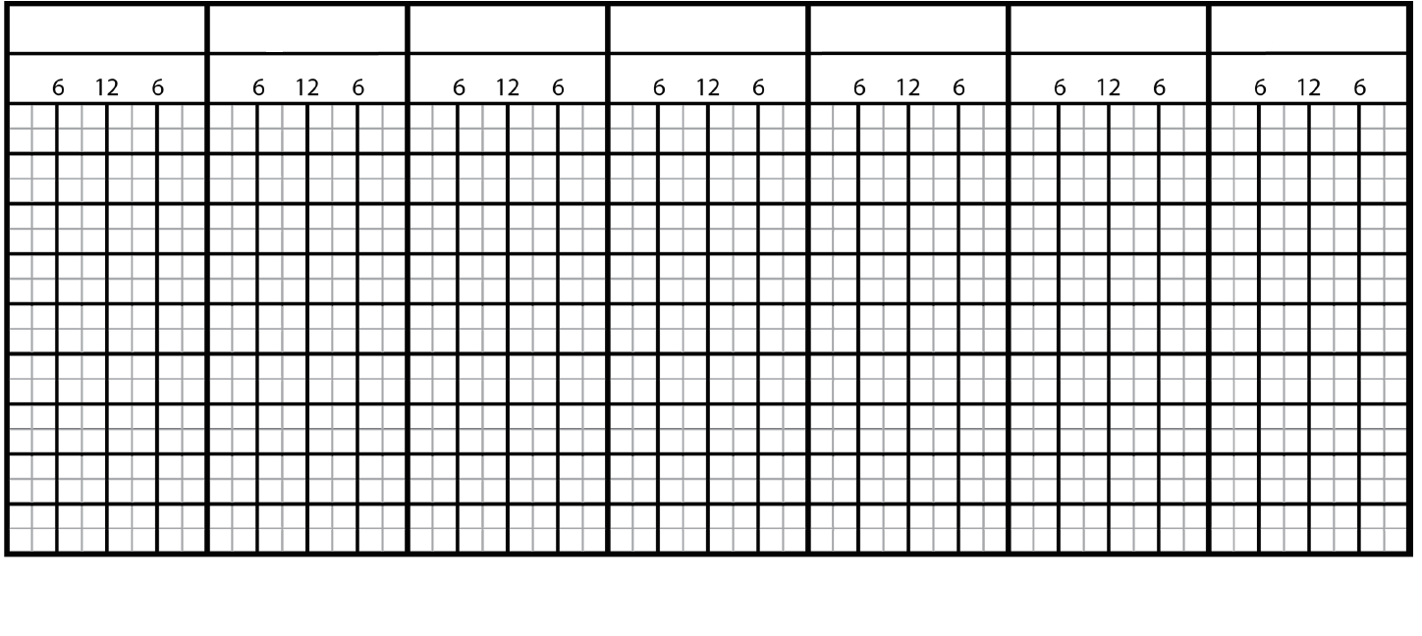

- Make sure that you label the y-axis!
- Mark on the graph either the Moon rise/sets OR the Moon’s zenith times.
- How does the HW time change over the week?

