**LAB 1.1 – Graphing Motion Name: …………..………………….…..**

Aim: To use your phone and a motion sensor to portray motion graphically

Method

1. Download a GPS app if you haven’t already installed one. I recommend a free app called ViewRanger. Use the settings to set units to km and km/hr.
2. Head outside, and ensure that the app has located you!
3. 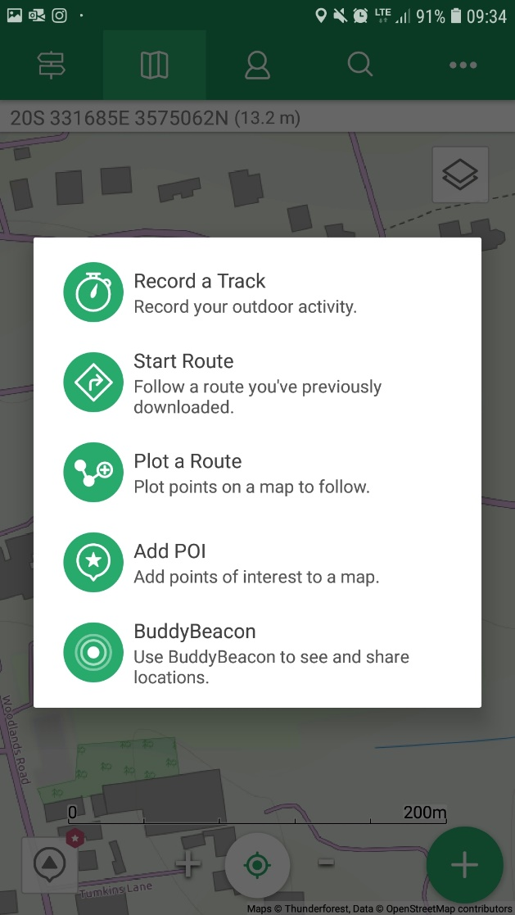Start the track feature by clicking the green + sign.

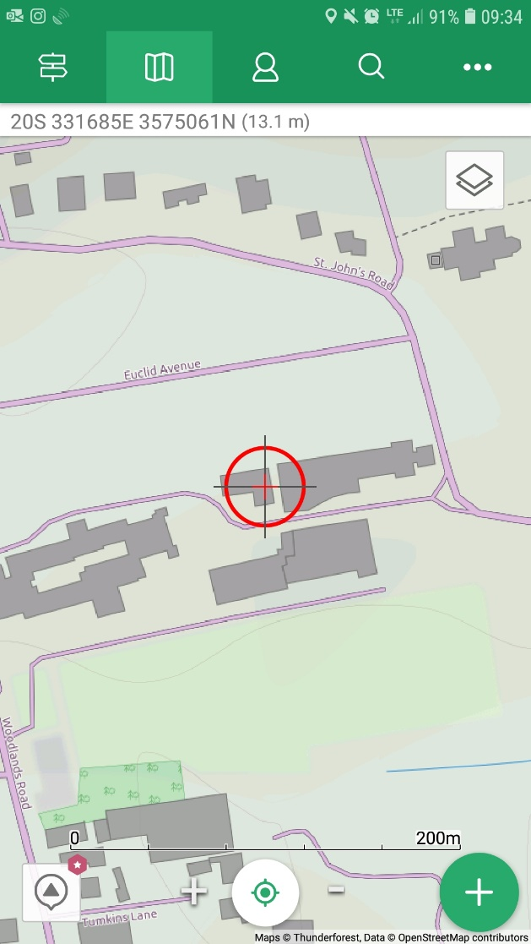

1. Record a track. Then select walking and start.
2. Stand still for a minute or so. Then start walking slowly for a few minutes.
3. Stand still again for a bit. Then run as fast as you can for a minute or so!
4. Finish the recording. Save the track under a suitable file name.
5. You can then inspect the data that the phone recorded. Summary will give you things like a) distance travelled, b) Max, average and min speeds and c) total time from start to finish. Viewing the graph should give you an idea of the variation of speeds. My example is from a walk in May, so won’t look the same.

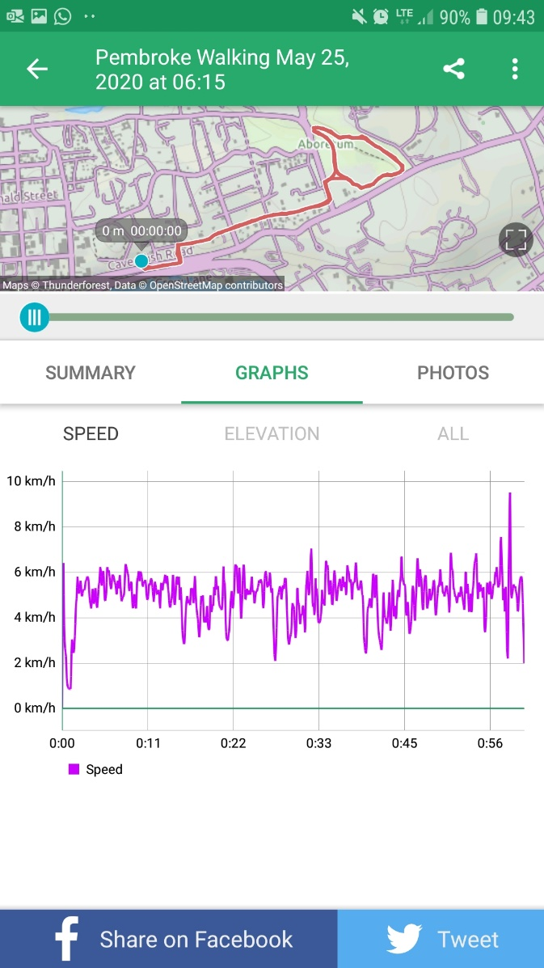

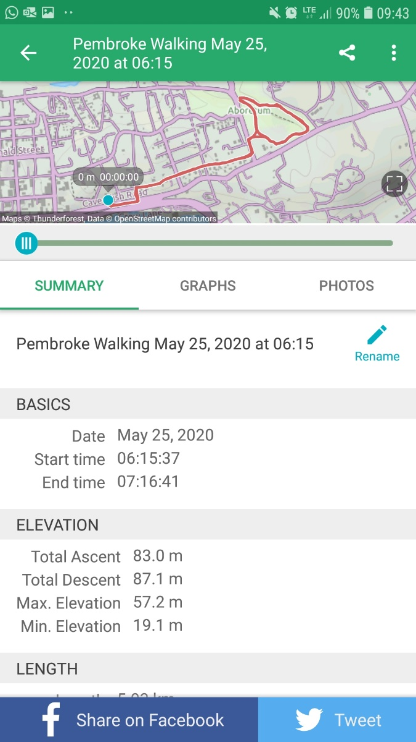

Fast!

Average

slow

1. Take a screenshot of your graph and data pages. Copy and paste them into your report. Describe how the graph matches your motion. Highlight the parts where your speed increases and decreases. (6 marks)
2. Restart the app and record a new track, but this time leave your phone on the ground (or a bag to keep dry). Leave for a few minutes. Stop the recording. When you zoom in close, what do you notice? Can you explain why this happens? (4 marks)
3. If you have a bike (if not, ask to get the screenshot of someone who does!), get on your bike and start the app running. Lock the phone and put it in your pocket! Ride up and down your private lane (if you have one). Hopefully there will be little traffic due to COVID…. Start off slowly for a few hundred meters. Say 5 km/hr. Then accelerate on a straight section steadily up to the campus speed limit of 20 km/hr. USE YOUR SPEEDOMETER. Try to maintain a steady speed. Towards the end, drop the speed and ride the last part slowly back to a stop.
4. Save the track and add the screenshots to your report. Highlight the graphs to show the periods of acceleration, slow speed, faster speed and deceleration. How does the GPS recorded speeds from the graphs compare with that of your speedometer? (6 marks)

What to hand in:

A short report of your experiments, included annotated screenshots of your graphs. Please send me a PDF version of your report to maintain formatting. Make sure that it has a suitable title and your name on it! You can add photos of you doing the experiment(s) if you wish. Description ( 4 marks)

Word: File 🡪 Save as 🡪 under file name you have an option to choose PDF.

Google Docs: File 🡪 Download 🡪 select PDF option

Total 20 marks