Assignment 7 – Circuits Name: …………………………………..

- Calculate the equivalent resistance between a and b. (2 marks)

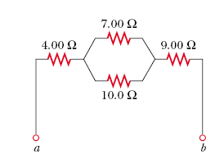

- Calculate the four currents in the circuit. Calculate the power dissipated by the battery. (7 marks).

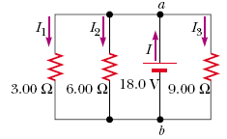

- Four resistors are connected to an 18 V battery as shown:
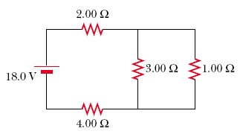

- Calculate the current from the 18.0 Volt supply. (3)

- Calculate the voltage across each resistor in the network. (4)

- Calculate the power dissipated through each resistor. (5).

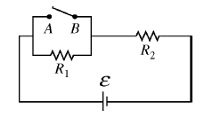
- Study the circuit below:

V

- Describe the effect of closing the switch between A and B. (2)

- The switch is open. What type of circuit is it? Let R₁ = 10 Ω and R₂ = 20 Ω with a voltage of 18 V provided by the battery. Calculate the overall current in the circuit. (2)

- Calculate the voltages across each of the resistors. (2)

- The switch is closed. What is the current now? (2)

- What is the voltage across
- R₂ (1)

- The switch (1)

- Explain why a short circuit can lead to a fire. What safety device can prevent a fire? (2)

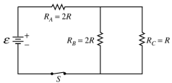

- The circuit above contains a battery with negligible internal resistance, a closed switch S, and three resistors, each with a resistance of R or 2R.

a. i. Rank the currents in the three resistors from greatest to least, with number 1 being greatest. If two resistors have the same current, give them the same ranking. (1)

_______I_{A} _______I_{B} _______I_{C}

ii. Justify your answers. (1)

b. i. Rank the voltages across the three resistors from greatest to least, with number 1 being greatest. If two resistors have the same voltage across them, give them the same ranking. (1)
_______V_{A} _______V_{B} _______V_{C}

ii. Justify your answers. (1)

For parts c. through e., use $E$= 12 V and R = 200 Ω.

c. Calculate the equivalent resistance of the circuit. (2)

d. Calculate the current in resistor R_{C}. (2)

