**Assignment 4 – Newton’s Laws Name ………………………………**

**Conceptual Question**

Two rock climbers of the same mass are hanging from a single length of rope secured at the top of the cliff. Where is the tension in the rope the greatest and why? (3) - Use a diagram to illustrate your answer.

**Multiple Choice (2)**

Assume the objects in the following diagrams have equal mass and the strings holding them in place are identical. In which case would the string be most likely to break?

` 

D. All would be

equally likely to

break

|  |
| --- |
| Space for scratch work |

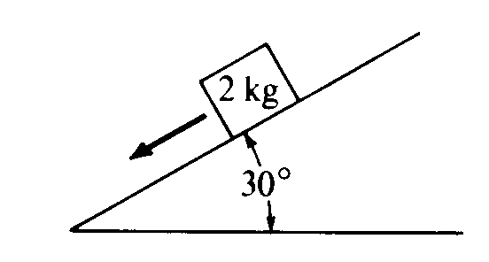

A 2 kg block is at rest on a slope. Which of the following diagrams best represents the gravitational force W. the frictional force f, and the normal force N that act on the block?  
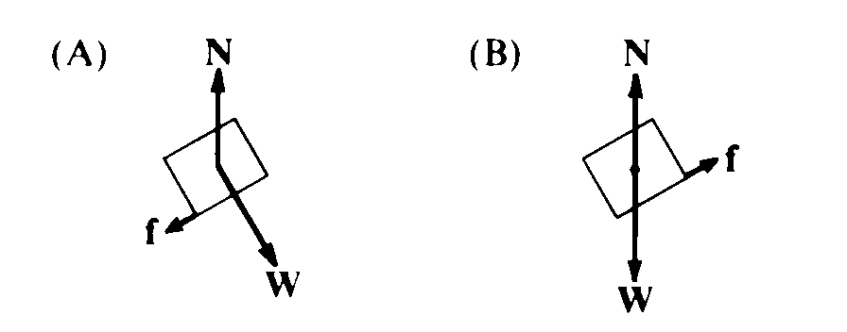 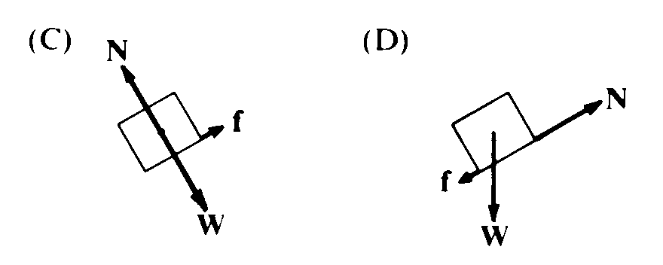 

(D)

**Free Response**

|  |  |
| --- | --- |
| Image result for bird on a wire cartoon |  |

1. A 5.0 kg bird is sitting on the centre of a BELCO cable. Ignore the little birds, I couldn’t find a better image….
2. Use a protractor to measure the angle of deflection of the wire. (1)
3. In the space provided, draw a neat free-body diagram of the bird and wire. (2)
4. Calculate the tension in the wire due to the bird assuming that the wire was straight beforehand. (3)
5. Draw a diagram to show what would happen if the bird was sitting ¼ of the way along the cable instead of in the centre. (2)

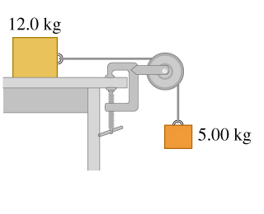

1. A 12.0 kg block is just held in equilibrium by a 5.0 kg block hanging over the bench as shown.
   1. Draw TWO free-body diagrams (one for each block), clearly showing the forces. (2)
   2. Calculate the friction required to just support the blocks. (2)
   3. Calculate the coefficient of static friction between the bench and the block (2).
2. Two blocks are on a frictionless surface as shown below. They are pulled by a force, *T1*, and accelerate to the right at 5 m/s2. Calculate the tensions T1 and T2. Explain your answer. (3)



1. A student is standing on a sensitive bathroom scale in an elevator. As the elevator accelerates upwards the reading changes. Does it get larger or smaller and why? Hint: draw a force diagram. (3)

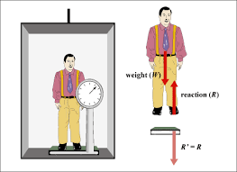

1. Two masses are hung from a light (aka massless) string over an ideal frictionless pulley. The masses are shown in various scenarios in the diagram below. Rank the acceleration of the systems from greatest to least. (4) [use format x > y = z etc]

***Hint: CALCULATE IT - do NOT TRY TO GUESS***





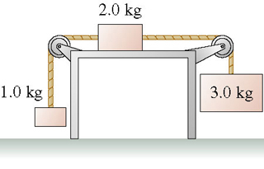

1. A system of 3 blocks is barely held in static equilibrium as shown above.
   1. Draw THREE free-body diagrams (one for each block), clearly showing the forces. (3)
   2. Calculate the friction required to just support the blocks. (2)
   3. Calculate the coefficient of static friction between the bench and the block (2).