Assignment 3 – Kinematics in 2-D Name ……………………….…..

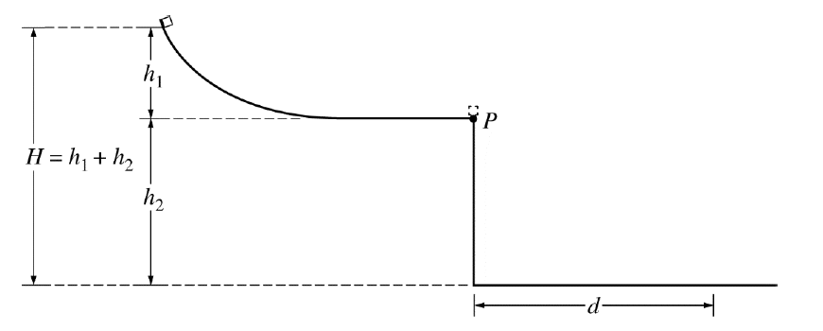
- A student releases a block from rest at the top of a slide of height, h₁. The block slides down the frictionless slide and off the end at point P, which is at a height, h₂, from the floor. The block hits the floor at a distance, d, from the end of the table. The overall height, H, is determined by the height of the lab ceiling and is fixed. The heights of the table and the slide are variable but must add up to the overall height H.

- Familiarize yourself with the experiment and sketch in the path of the block as it leaves the slide. Air resistance and friction are negligible. (1)

- Explain, without using any equations, why making the slide height, h₁, short would cause the range, d, to be small even though the height of the table, h_{2,} would be large. (3)

- Explain, without using any equations, why making the table height, h₂, short would cause the range, d, to be small even though the height of the slide, h_{1,} would be large. (3)

- A Barcelona football player kicks a ball at a goal that is 32 m away as shown above. The ball is initially at rest and it leaves the player's foot at 20 m/s at an angle of 54° above the horizontal. Ignore the height of the goal (for now).

- Calculate the horizontal and vertical components of the initial velocity of the ball. (2)

- Determine the time it takes for the ball to reach the plane of the goal. (3)

- Will the ball reach the goal? If not, does it fall short or pass over the goal? (3)

- Assuming that the angle that the ball is kicked at is constant, does he need to kick the ball harder or softer to score? Explain. (2)

- How would factoring in the vertical height of the net affect the speed and/or angle that the footballer needs to score a goal? (2)

- Projectile motion is not just about cannonballs and footballs. It also works for jets of water. At home, produce a jet of water that forms a parabolic arc. The easiest way is to produce a horizontal jet. Methods could include: poke a hole in an empty soda bottle near the bottom, fill with water and set on a wall. You could have a family member hold a garden hose pipe steady. Measure the height of jet above the ground and the distance the jet goes. Take a photo and include it in your report. From this data, calculate the speed of the water from the jet as it leaves either the bottle or the hose pipe.

If you want an extra challenge, angle the hose upwards, measure the angle and repeat the calculation. You should get the same result. (Note: over a distance the air drag can affect the speed of the droplets – ignore this)

