**Assignment 2 - Hydrodynamics Name: …………………………………**



1. The speed of an ideal fluid is marked as it moves along a horizontal streamline through a pipe, as shown in the figure. In Region I, the speed of the fluid on the streamline is *v*. The cylindrical, horizontal pipe narrows so that the radius of the pipe in Region II is half of what it was in Region I. What is the speed of the marked fluid when it is in Region II?

(A) 4*v* (B) 2*v* (C) *v*/2 (D) *v*/4

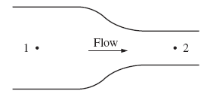

1. A fluid flows steadily from left to right in the pipe shown. The diameter of the pipe is less at point 2 then at point 1, and the fluid density is constant throughout the pipe. How do the velocity of flow and the pressure at points 1 and 2 compare?

Velocity Pressure

(A) *v*1 < *v*2 *p*1 = *p*2

(B) *v*1 < *v*2 *p*1 > *p*2

(C) *v*1 = *v*2 *p*1 < *p*2

(D) *v*1 > *v*2 *p*1 = *p*2



1. Water flows in a pipe of uniform cross-sectional area *A*. The pipe changes height from *y1* = 2 m to *y2* = 3 m. Since the areas are the same, we can say *v1* = *v2*. Which of the following is true?

(A) *P1 = P2 + ρg(y2– y1)*

(B) *P1* = *P2*

(C) *P1* = 0

(D) *P2* = 0



1. A 20 m high dam is used to create a large lake. The lake is filled to a depth of 16 m as shown above. The density of water is 1000 kg/m3.
2. Calculate the absolute pressure at the bottom of the lake next to the dam. (2)

A release valve is opened 5.0 m above the base of the dam, and water exits horizontally from the valve.

1. Use Torricelli’s Theorem to calculate the initial speed of the water as it exits the valve. (3)
2. The stream below the surface of the dam is 2.0 m deep. Assuming that air resistance is negligible, calculate the horizontal distance *x* from the dam at which the water exiting the valve strikes the surface of the stream. (3)
3. Suppose that the atmospheric pressure in the vicinity of the dam increased. How would this affect the initial speed of the water as it exits the valve? (Circle correct answer) (1)

|  |  |  |
| --- | --- | --- |
| It would increase. | It would decrease | It would remain the same |

Justify your answer. (2)



An underground pipe carries water of density 1000 kg/m3 to a fountain at ground level, as shown above. At point *A*, 0.50 m below ground level, the pipe has a cross-sectional area of 1.0 x 10-4 m2. At ground level, the pipe has a cross-sectional area of 0.50 x 10-4 m2. The water leaves the pipe at point *B* at a speed of 8.2 m/s.

(a) Calculate the speed of the water in the pipe at point *A*. (2)

(b) Calculate the absolute water pressure in the pipe at point *A*. (2)

(c) Calculate the maximum height above the ground that the water reaches upon leaving the pipe vertically at ground level, assuming air resistance is negligible. (3)

(d) Calculate the horizontal distance from the pipe that is reached by water exiting the pipe at 60° from the level ground, assuming air resistance is negligible. (3)

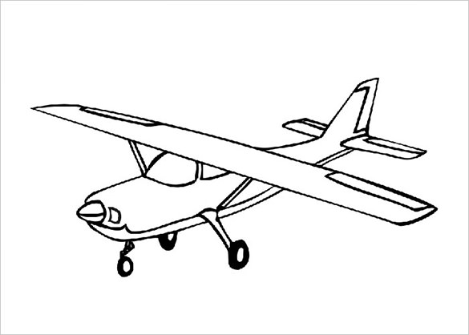

A small airplane has wings with surface area 9 m2 each. The speed of the air across the top of the wing is 50 m/sec, and across the bottom of the wing, 40 m/sec. Take the density of air to be 1.2 kg/m3.

1. Find the difference in the pressure between the top and the bottom of the wing. (2)
2. Find the net lift upward on the plane. (remember that there are TWO wings) (2)
3. If there is no other lift on the plane, what would be the mass of the plane?

Assume the plane is not accelerating up or down. (2)