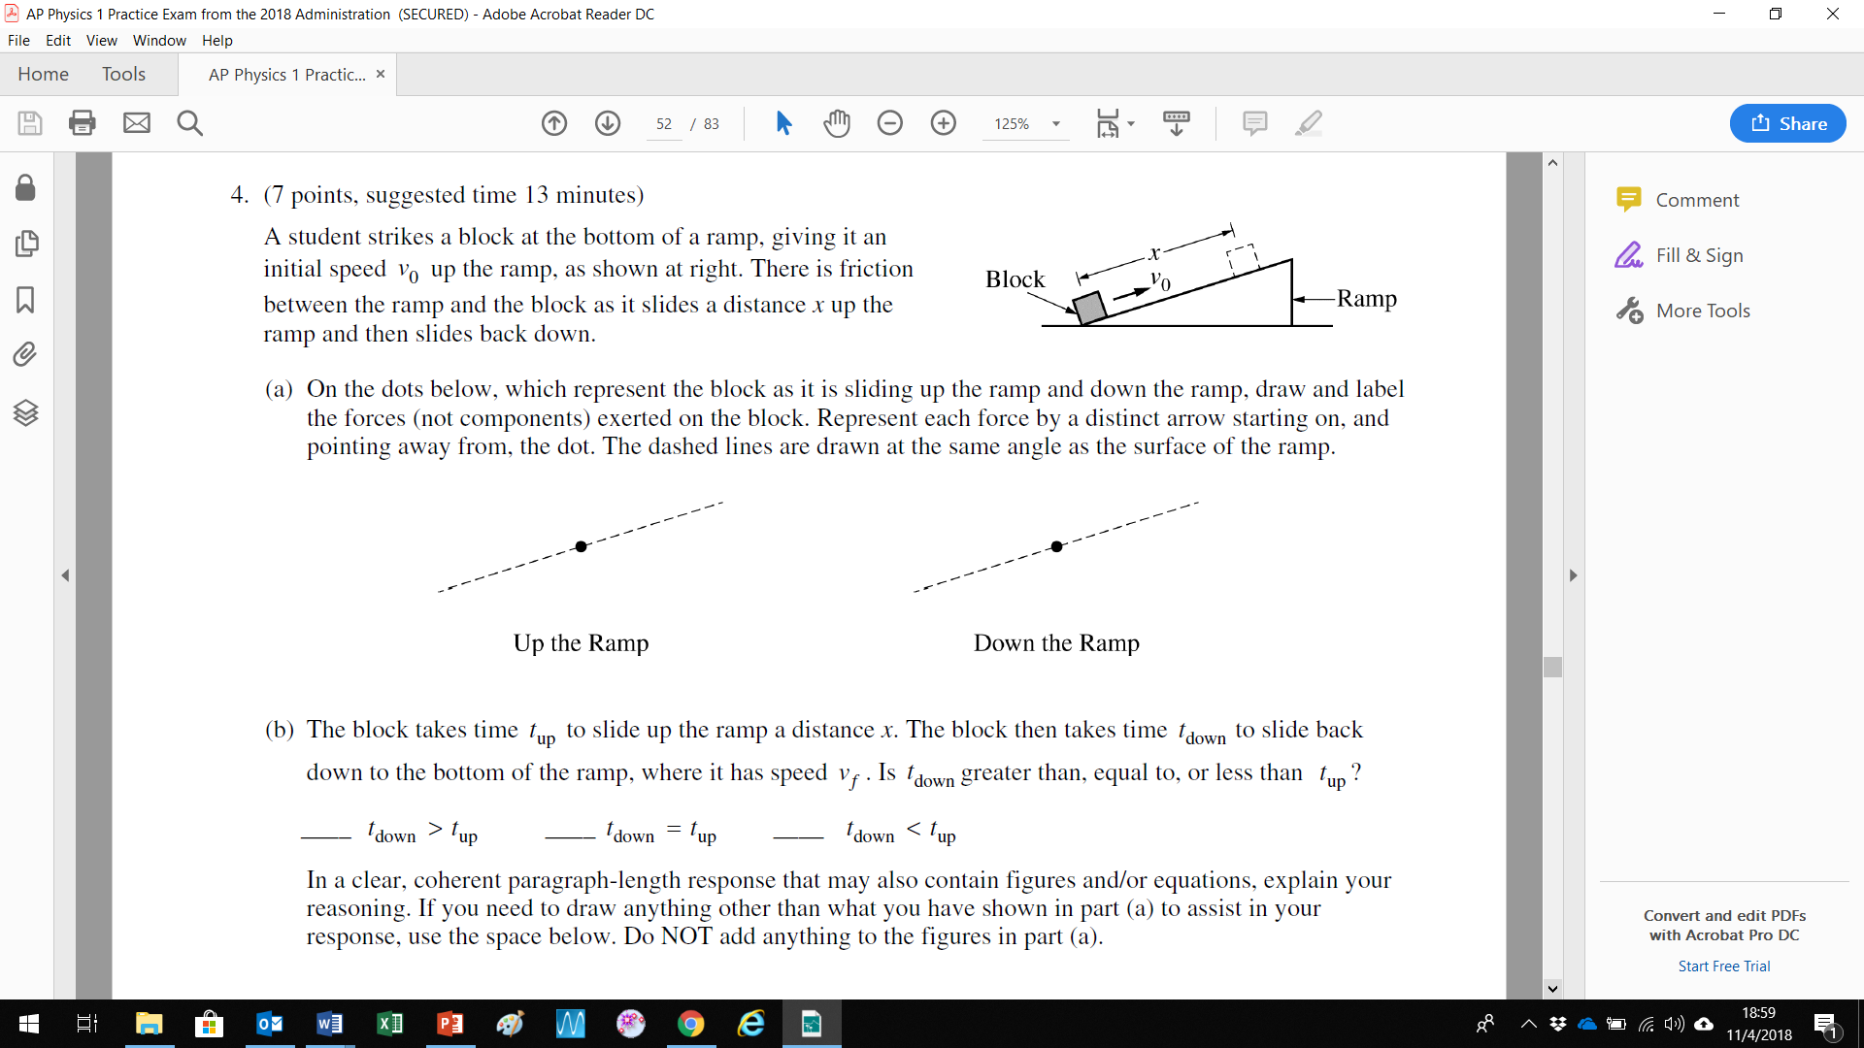θ

This is a good example of read and understand the question BEFORE you attempt the answer. At the start of the question the block is already moving, the student HAS hit it, now it is disconnected from the student. I would have done some scratch work at the top of the page (or on the back page…)

You have TWO tasks:

1. Work through the question on the left side of the paper.
2. Repeat the question but do it more thoroughly and mathematically. Set the angle to *θ* = 20°, the coefficient of friction to *µ =* 0.3, the mass *m* = 1.2 kg and *vo* = 3.0 m/s and calculate i) the distance x and ii) the times up and down the slope.

Mean = 1.61

Name:

(5 marks)

(2 marks)