HW 14.2 – Forces in a B-field Name: …………………………………
Set: Monday 30 November 2020
Due: Friday 4 December 2020
Reading
Island Physics Magnetism sections 14.1 – 14.3 and College Physics chapter 19, sections 19.1 – 19.4
$$F_{B}=BIl$$  $$F_{B}=Bqv$$  $$F_{E}=qE$$  $$PE_{E}=qV$$ | $$μ_{0}=4π×{10}^{-7}$$  $$e=1.6×{10}^{-19}\text{ C}$$  $$F_{c}=\frac{mv^{2}}{r}$$

- A proton travels at a speed of 2.5 × 10⁶ m/s through a uniform magnetic field of strength 50mT. If the proton travels at an angle of 25˚ to the field calculate the force on the proton. Calculate the initial acceleration of the proton when entering this field. (3)

- The velocity of a particle of charge +4.0 × 10⁻⁹ C and mass 2 × 10⁻⁴ kg is perpendicular to a 0.1 T magnetic field. If the particle’s speed is 3 × 10⁴ m/s; what is the acceleration of the particle due to the magnetic force? (3)

- A charged particle enters the magnetic field of a mass spectrometer at a speed of 2.5 × 10⁶ m/s. It then traces out a circular path of radius 15 cm in a uniform magnetic field of magnitude 0.45 T having a direction perpendicular to the particle’s velocity. Find the particles charge to mass ratio. If a second particle with twice the charge-to-mass ratio enters the field with half the velocity, calculate the radius of its path. (4)

- An electron is accelerated through 2400 V from rest and then enters a region where there is a uniform 1.70 T magnetic field. What is the magnitudes of the magnetic force acting on this electron? (2)

- Determine the initial direction of the deflection of charged particles entering the magnetic fields shown below (4)
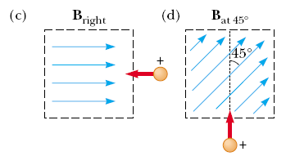
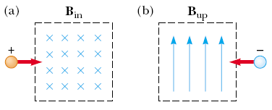

- A wire 2.80 m in length carries a current of 5.00 A in a region where a uniform magnetic field has a magnitude of 0.390 T. Calculate the magnitude of the magnetic force on the wire assuming the angle between the magnetic field and the current is

- 60.0° (1)

- 90.0° (1)

- 120° (1)

- A current of 15 A is directed along the positive x-axis and perpendicular to a magnetic field. A magnetic force per unit length of 0.12 N/m acts on the conductor in the negative y-direction. Calculate the magnitude of the magnetic field in the region through which the current passes. (3)

- A rod of mass 0.720 kg rests on two parallel rails that are d = 0.12 m apart and L = 0.45 m long. The rod carries a current of I = 48.0 A (in the direction shown) and slips along the frictionless rails under the action of the resultant force. A uniform magnetic field of magnitude 0.240 T is directed perpendicular to the rod and the rails. If it starts from rest, what is the speed of the rod as it leaves the rails? (4)

