HW 13.5 – Electric Fields Name: ……………………………………

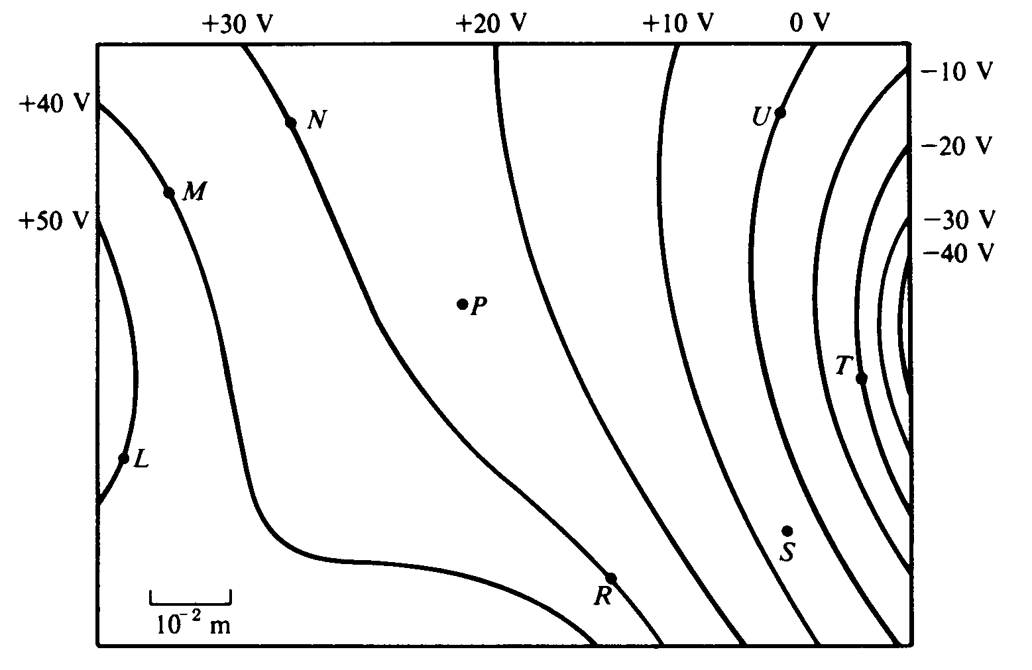

Three point charges produce the electric equipotential lines shown on the diagram above.

- Draw arrows at points L, N. and U on the diagram to indicate the direction of the electric field at these points. (3) USE A PENCIL

- At which of the lettered points is the electric field E greatest in magnitude? Explain your reasoning. (2)

- Compute an approximate value for the magnitude of the electric field E at point P. (2)

- Compute an approximate value for the potential difference, V_{M} – V_{S}, between points M and S. (2)

- Determine the work done by the field if a charge of +5 × 10^{–12} C is moved from point M to point R. (3)

- If the charge of +5 × 10^{–12} C were moved from point M first to point S, and then to point R, would the answer to e) be different, and if so, how? (2)

