CW 13.10 – Electron Paths Name: ……………………………………

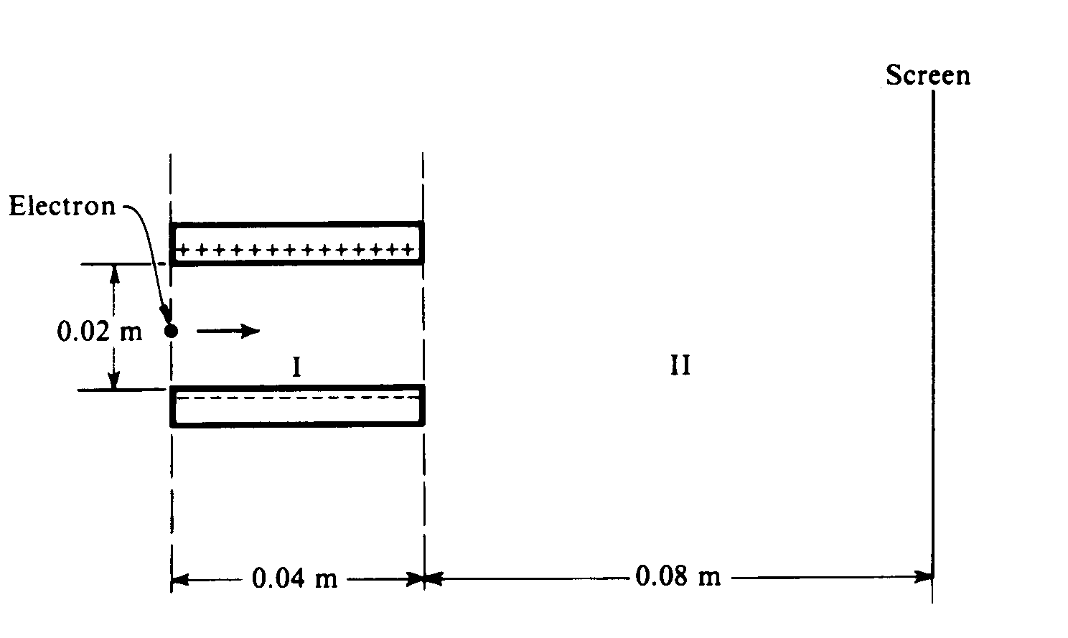
An electron initially moves in a horizontal direction and has a kinetic energy of 2.0 x 10³ eV when it is in the position shown above. It passes through a uniform electric field between two oppositely charged horizontal plates (region I) and a field-free region (region II) before eventually striking a screen at a distance of 0.08 m from the edge of the plates. The plates are 0.04 m long and are separated from each other by a distance of 0.02 m. The potential difference across the plates is 250 V. Gravity is negligible.

- Calculate the initial speed of the electron as it enters region I. (2)

- Calculate the magnitude of the electric field E between the plates, and indicate its direction on the diagram above. (2)

- Calculate the magnitude of the electric force F acting on the electron while it is in region I. (2)

- On the diagram below, sketch the path of the electron in regions I and II. For each region describe the shape of the path. (2)
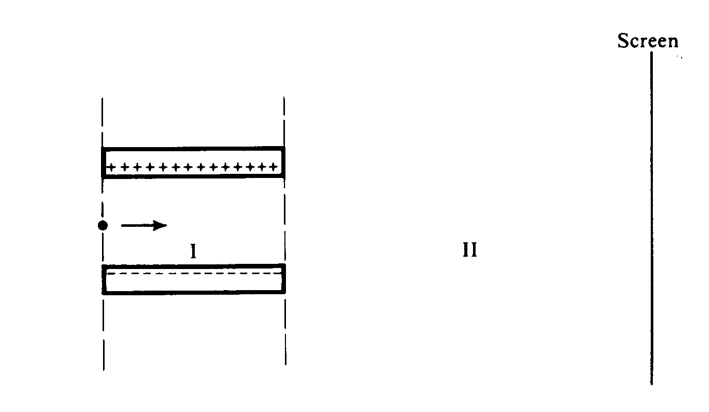

- Calculate the vertical distance from the centre-line that the electron strikes the screen. (3)

