**Assignment 9 - Electromagnetic Induction Name: ………………………………….**

1. A square loop of 2.00 m on a side is placed in a magnetic field of magnitude 0.300 T. If the field makes an angle of 50.0˚ with the normal to the plane of the loop, find the magnetic flux through the loop. (2)
2. A coil of radius 5.0 cm is constructed from 10 turns of wire. If the magnetic field strength changes from zero to 1.2 mT in four seconds, calculate the induced EMF. (2)
3. A square, single-turn coil of 0.15 m on a side is placed with its plane perpendicular to a constant magnetic field. An emf of 25 mV is induced the coil winding when the area of the coil decreases at the rate of 0.14 m2/s. What is the magnitude of the magnetic field? (2)



4.0 m/s

0.65 T

0.30 m

2.5 Ω

1. A sliding bar, has a length of 0.300 m and moves at 4.00 m/s in a magnetic field of magnitude 0.650 T. Using the concept of motional emf, find the induced voltage in the moving rod. If the resistance in the circuit is 2.50 Ω, find the current in the circuit and the power delivered to the resistor. (3)
2. An automobile has a vertical radio antenna 1.50 m long. The automobile travels at 20 m/s on a horizontal road where the Earth’s magnetic field is 40.0 µT directed toward the north and downward at an angle of 55.0° below the horizontal.
3. Specify the direction that the automobile should move in order to generate the maximum motional emf in the antenna, with the top of the antenna positive relative to the bottom. (2)
4. Calculate the magnitude of this induced emf. (2)
5. A bar magnet is held above the centre of a wire loop lying in the horizontal plane, as shown in the figure below. The south end of the magnet is toward the loop. After the magnet is dropped, what is the direction of the induced current in the loop as viewed from above – multiple choice (2)?

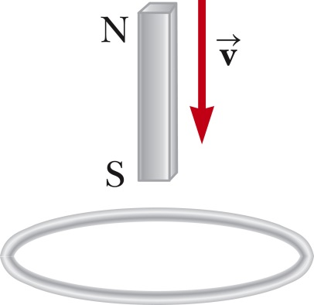

1. It is clockwise as the magnet falls toward the loop.
2. It is counter clockwise as the magnet falls toward the loop.
3. It is clockwise after the magnet has moved through the loop and moves away from it.
4. It is always clockwise.
5. It is first counter clockwise as the magnet approaches the loop and then clockwise after it has passed through the loop.
6. The diagram shows a top view of a bar that can slide without friction. The resistor is 6.00 Ω and a 2.50-T magnetic field is directed perpendicularly downward, into the paper. Let l = 1.20 m.

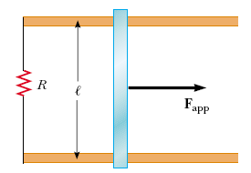

1. Calculate the applied force required to move the bar to the right at a constant speed of 2.00 m/s. (2)
2. At what rate is energy delivered to the resistor? (2)
3. A charged particle enters the magnetic field of a mass spectrometer at a speed of 2.5 × 106 m/s.  It then traces out a circular path of radius 0.15 m in a uniform magnetic field of magnitude 0.45 T having a direction perpendicular to the particle’s velocity.  If the particle has a charge of 1.6 x 10-19 C, find its mass. (3)