**Assignment 8 – B-fields Name: …………………………………..**

1. A long straight wire conductor is placed below a compass as shown in the top view figure. When a large conventional current flows in the conductor as shown, the N pole of the compass:

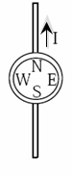A) has its polarity reversed

B) points to the south  
C) points to the west

D) points to the east

1. 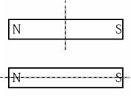Two bar magnets are to be cut in half along the dotted lines shown. None of the pieces are rotated. After the cut:

A) The two halves of each magnet will attract each other  
B) The two halves of each magnet will repel each other  
C) The two halves of the top magnet will repel, the two halves of the bottom magnet will attract  
D) The two halves of the top magnet will attract, the two halves of the

1. 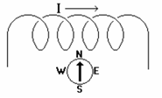A compass is placed near a coil of wire. A conventional electrical current is then run through the coil from left to right as shown. This will cause the North pole of the compass to:

A) point toward the left  
B) point toward the right  
C) point toward the bottom of the paper  
D) not move since the magnetic field of the coil is into the paper

1. 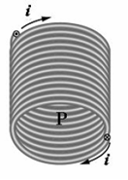The magnetic field line passing through point P inside the solenoid is directed

A) to the right  
B) to the left  
C) downward toward the bottom of the page

D) upward toward the top of the page

1. A rectangular wire loop is connected to a power supply with a voltage of 16 V. The wire has a resistivity 1.7 x 10-8 Ωm and a cross-sectional area 3.5 x 10-9 m2. When the supply is turned on the current is 4.0 A.
2. Calculate the length of wire used. (3)

The wire is then used in an experiment to measure the strength of a magnetic field. The magnet is placed on a digital balance and the wire loop is held fixed between the poles of the magnet – as shown above. The length of the wire between the poles is 0.020 m.



1. Which direction is the force on the MAGNET due to the current in the wire? Explain. (2)
2. The reading on the balanced changed by 0.060 N when the power supply was turned on. Calculate the strength of the magnetic field. (3)
3. A wire 2.80 m in length carries a current of 5.00 A in a region where a uniform magnetic field has a magnitude of 0.390 T. Calculate the magnitude of the magnetic force on the wire assuming the angle between the magnetic field and the current is
4. 60.0° (1)
5. 90.0° (1)
6. 120°. (1)
7. A wire carries a current of 10 A in a direction that makes an angle of 30˚ with the direction of a magnetic field of strength 0.300 T. Find the magnetic force on a 5.0 m length of the wire. (3)

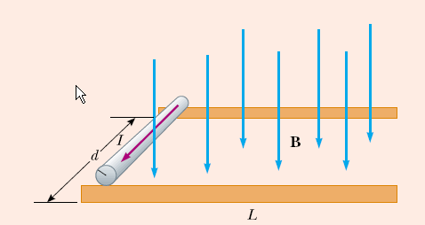

1. A rod of mass 0.720 kg rests on two parallel rails that are *d* = 12.0 cm apart and *L* = 45.0 cm long. The rod carries a current of *I* = 48.0 A (in the direction shown) and slips along the frictionless rails under the action of the magnetic force. A uniform magnetic field of magnitude 0.240 T is directed perpendicular to the rod and the rails. If it starts from rest, what is the speed of the rod as it leaves the rails? (3)