**Assignment 4 – Newton’s Laws Name MARK SCHEME**

**Conceptual Question**

Two rock climbers of the same mass are hanging from a single length of rope secured at the top of the cliff. Where is the tension in the rope the greatest and why? (3) - Use a diagram to illustrate your answer.

Suitable diagram.

Upper rope is supporting the weight of both climbers, whereas the lower rope is only supporting the weight of one climber.

**Multiple Choice (2)**

Assume the objects in the following diagrams have equal mass and the strings holding them in place are identical. In which case would the string be most likely to break?

` 

D. All would be

equally likely to

break

|  |
| --- |
| B – as the angle gets shallower, the tension required to maintain the vertical component that counteracts the weight W, must increase. In terms of maths: $$F↑= F ↓$$ $$2T\sin{θ}=W$$ Therefore $$T=\frac{W}{2\sin{θ}}$$ As $θ ↓0 T ↑$ |

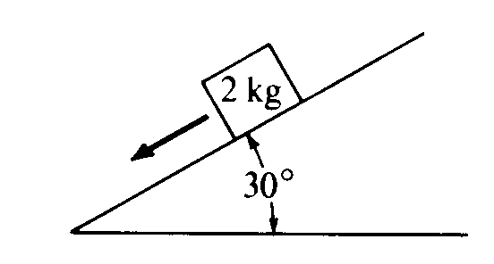

A 2 kg block is at rest on a slope. Which of the following diagrams best represents the gravitational force W. the frictional force f, and the normal force N that act on the block?  
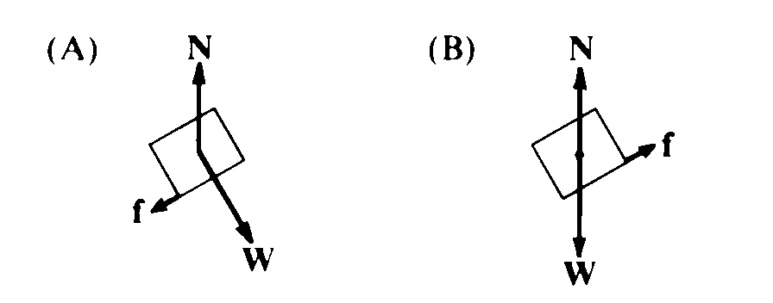 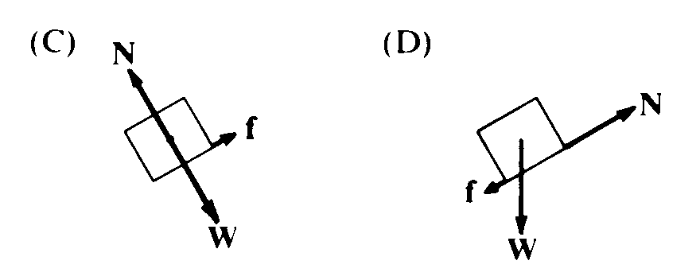 

(D)

D – weight acts vertically downwards, the normal is perpendicular to the slope and friction acts against the motion.

**Free Response**

|  |  |
| --- | --- |
| Image result for bird on a wire cartoon |  |

1. A 5.0 kg bird is sitting on the centre of a BELCO cable. Ignore the little birds, I couldn’t find a better image….
2. Use a protractor to measure the angle of deflection of the wire. (1)

The angle is about 20° - allow a few degrees either side.

1. In the space provided, draw a neat free-body diagram of the bird and wire. (2)

Suitable. Forces to be identified and labeled – weight of bird, tensions in both wires. Angle to be referenced and labeled.

1. Calculate the tension in the wire due to the bird assuming that the wire was straight beforehand. (3)

$$F↑= F ↓$$

$$2T\sin{θ}=W$$

Therefore

$$T=\frac{W}{2\sin{θ}}$$

$$T=\frac{\left(5×10\right)}{2×\sin{20}}$$

$$T=73\text{N}$$

Allow for error with the angle.

1. Draw a diagram to show what would happen if the bird was sitting ¼ of the way along the cable instead of in the centre. (2)

Diagram should show an asymmetric sag

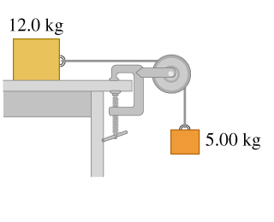

1. A 12.0 kg block is just held in equilibrium by a 5.0 kg block hanging over the bench as shown.
   1. Draw TWO free-body diagrams (one for each block), clearly showing the forces. (2)

Suitable FBD of both blocks

* 1. Calculate the friction required to just support the blocks. (2)

Easy method:

$$F ←= F →$$

$$f = mg = 5×10 = 50N$$

Method using simultaneous equations given equal credit

* 1. Calculate the coefficient of static friction between the bench and the block (2).

$$f = μN$$

$$μ=\frac{f}{N}$$

$$μ=\frac{50}{\left(12×10\right)}=0.42$$

1. Two blocks are on a frictionless surface as shown below. They are pulled by a force, *T1*, and accelerate to the right at 5 m/s2. Calculate the tensions T1 and T2. Explain your answer. (3)



Total mass = 7 kg,

$$F = ma$$

$$T_{1}=7×5=35\text{N}$$

Repeating for the 2 kg block,

$$F = ma$$

$$T_{2}=2×5=10\text{N}$$

Credit given for any other method

1. A student is standing on a sensitive bathroom scale in an elevator. As the elevator accelerates upwards the reading changes. Does it get larger or smaller and why? Hint: draw a force diagram. (3)

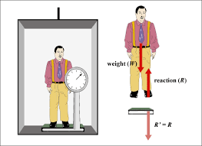

The reading increases as it is the normal force that is measured by the scale.

$$F = ma$$

The force exerts a larger force on the person as it has to accelerate him,

$$N - mg = ma$$

$$N = ma + mg$$

Therefore the normal force has got larger than his weight.

1. Two masses are hung from a light (aka massless) string over an ideal frictionless pulley. The masses are shown in various scenarios in the diagram below. Rank the acceleration of the systems from greatest to least. (4) [use format x > y = z etc]

***Hint: CALCULATE IT - do NOT TRY TO GUESS***



These examples require calculations:

Eg System A

$$a=\frac{\sum{F}}{m}$$

$$a=\frac{\left(50-10\right)}{\left(5+1\right)}=6.7{\text{m}\text{/}\text{s}}^{2}$$

Common error is to forget that the resultant force has to accelerate the TOTAL mass



**A > D = F > B > C = E**

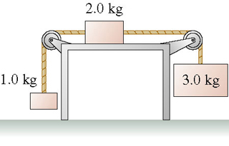

1. A system of 3 blocks is barely held in static equilibrium as shown above.
   1. Draw THREE free-body diagrams (one for each block), clearly showing the forces. (3)

Suitable

* 1. Calculate the friction required to just support the blocks. (2)

Easiest method:

$$F ←= F →$$

$$10+f = 30$$

$$f=20\text{N}$$

Full credit for any other method that gets the same answer

* 1. Calculate the coefficient of static friction between the bench and the block (2).