**Assignment 1 - Hydrostatics Name:……………………………...**

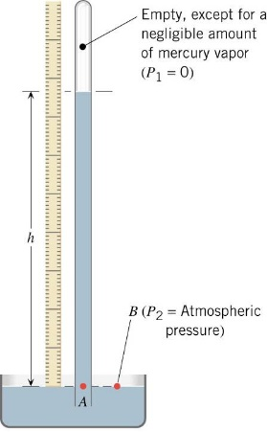

1. Calculate the length of a column of Mercury that is equivalent to normal air pressure. (2)
2. Two gases are connected to a U-tube manometer containing water. If one gas is held at a pressure of 1.5 × 105 Pa and the second at 3.5 × 105 Pa what will be the difference in height of the water from one side of the manometer to the other? (2)

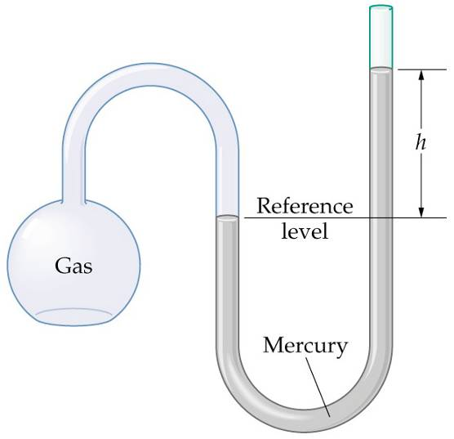

1. A glass contains layers of oil (density = 800 kg/m3) water and mercury. Draw a diagram. If each layer is 8.0 cm thick what is the gauge pressure at a depth of 2.0 cm from the bottom of the glass? (3)
2. A water pump reduces the air pressure from its normal atmospheric value to 6 × 104 Pa. If the pump is used to empty water from a 5.0 m deep Olympic diving pool can it draw up all of the water? If not how much water will be left in the pool? (3)

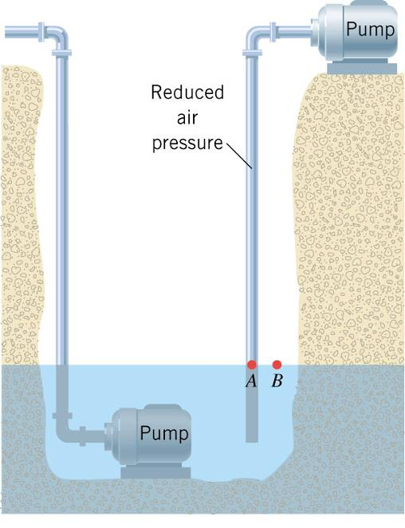

1. 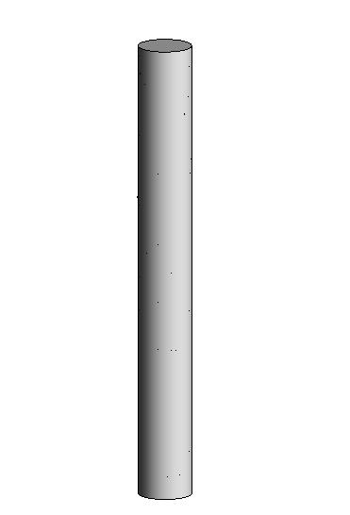If 1.0 m3 of concrete weighs 5.0 × 104 N, what is the height of the tallest cylindrical concrete pillar (radius 56.4 cm) that will not collapse under its own weight? The compression strength of concrete (the maximum pressure that can be exerted on the base of the structure) is 1.7 × 107 Pa. (3)



1. Three objects of identical mass attached to strings are suspended in a large tank of liquid, as shown above.
2. Must all three strings have the same tension?

____ Yes ____ No

Justify your answer. (2)

Object A has a volume of 1.0 x 10-5 m3 and a density of 1300 kg m3. The tension in the string to which object A is attached is 0.0098 N.

1. Calculate the buoyant force on object A. (2)
2. Calculate the density of the liquid. (2)
3. Some of the liquid is now drained from the tank until only half of the volume of object A is submerged.

Would the tension in the string to which object A is attached increase, decrease, or remain the same?

____ Increase ____ Decrease ____ Remain the same

Justify your answer. (3)

1. A copper block of dimensions 3.0 cm by 2.0 cm by 4.0 cm is taken from a lab bench and placed into a beaker of tap water so that the water covers the entire block. Calculate the buoyant force (upthrust) on the block in both air and water. If the copper is suspended by a light inextensible string from a force meter, what will be the readings on the meter in air and water? The density of air is 1.29 kg/m3 and the density of copper is 8.92 × 103 kg/m3. (4)
2. The cup on the right has an iron coin placed on top of the ice cube. What will happen to the water level in the two glasses when the ice melts? (3)

